**Challenge 2**

[www.pythonchallenge.com/pc/def/ocr.html](http://www.pythonchallenge.com/pc/def/ocr.html)

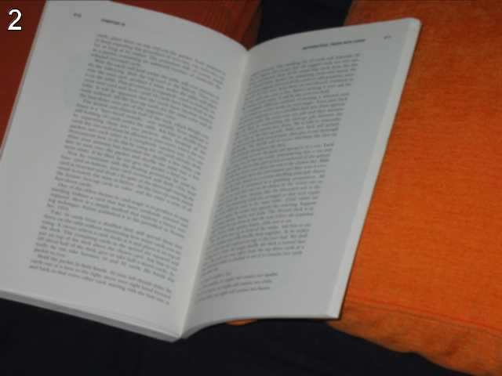  
recognize the characters. maybe they are in the book,  
but MAYBE they are in the page source.

I squinted at this for a while and couldn’t make anything of it. Then thought maybe ‘page source’ in the hint means the webpage source. In my browser (Microsoft edge) I can right-click on a page and see the source. You can also do this with **requests.get(url).text**.

Anyway, looking at the source for the page, there’s this:

<!--

find rare characters in the mess below:

-->

<!--

%%$@_$^__#)^)&!_+]!*@&^}@[@%]()%+$&[(_@%+%$*^@$^!+]!&_#)_*}{}}!}_]$[%}@[{_@#_^{*

@##&{#&{&)*%(]{{([*}@[@&]+!!*{)!}{%+{))])[!^})+)$]#{*+^((@^@}$[**$&^{$!@#$%)!@(&. . .

The only idea I could come up with was to count the frequency of all the characters in the mess. Printing these, the letters in ‘equality’ all have frequency 1. Plugging that into the url, it works. On to challenge 3.